
Vol.12 No.2 (2026) 27-37
ISSN: 2460-4348, e-ISSN: 2549-7162
https://jurnal.ar-raniry.ac.id/index.php/jurnalphi/index

Article Type: original research

Mapping of Physicochemical Properties of Well and River Water in Sayang and Cikeruh Villages, Sumedang Regency

Maharani Arisandy^{1*}, Dini Fitriani^{2*}, Eleonora Agustine², Kartika Hajar Kirana², Luthfi Tanton Atthailah¹, Shafa Maura Fidela¹, Alden Rizqi Pamula¹, Raya Putra Sang Fajar¹
¹Study Program of Geophysics, Faculty of Mathematics and Natural Sciences, Universitas Padjadjaran, Sumedang, Indonesia
²Department of Geophysics, Faculty of Mathematics and Natural Sciences, Universitas Padjadjaran, Sumedang, Indonesia

Correspondence E-mail: dini.fitriani@unpad.ac.id, maharani22003@mail.unpad.ac.id

ARTICLE INFO | ABSTRACT
Article History:  Received: 16 February 2026  Revised: 01 April 2026  Accepted: 03 April 2026  Published: 08 April 2026  Keywords:  Water quality; Physicochemical properties; Well water; Cikeruh river; Jatinangor   | Water is an essential resource for human life, yet its quality has declined due to population growth and land-use changes. Sayang and Cikeruh Villages in Jatinangor District have experienced environmental pressures from land conversion and domestic activities that may affect groundwater and surface water quality. This study aims to map and analyze the physicochemical parameters of water, including temperature, pH, electrical conductivity (EC), and total dissolved solids (TDS), in well water and the Cikeruh River. Measurements were conducted at ten well and nine river sampling points and analyzed using descriptive, spatial, and multivariate methods. The results show that most well water samples meet clean water quality criteria; however, several locations exhibit elevated EC and TDS values and slightly acidic pH, indicating the influence of surrounding residential activities. In contrast, river water quality remains within acceptable limits for all measured parameters. Multivariate analysis reveals a strong correlation between EC and TDS in both well and river water, indicating their importance as key indicators of water quality. Spatial analysis shows that water quality in the southern part of the study area tends to be lower than in the northern part. Continuous monitoring and appropriate water resource management are therefore necessary to maintain water quality in the study area.
 | This work is licensed under a Creative Commons Attribution-ShareAlike 4.0 International License

- INTRODUCTION
Sayang and Cikeruh Villages, located in Jatinangor District, have experienced rapid development driven by urbanization and the expansion of higher education institutions. The conversion of agricultural land into dense residential and commercial areas has significantly affected environmental quality, particularly water resources. In these villages, the Cikeruh River and domestic wells constitute the primary sources of water for daily household activities. However, population growth accompanied by intensified anthropogenic activities has the potential to degrade water quality through pollution, uncontrolled land use changes, and agricultural runoff. This is consistent with findings indicating that urban development and land-use changes are key factors influencing groundwater quality in rapidly developing areas (Maria et al., 2024). Furthermore, groundwater pollution is generally persistent and difficult to remediate once contamination occurs, highlighting the long-term environmental risks associated with such changes (Xie et al., 2024). These conditions underscore the importance of a deeper understanding of water quality in affected areas. Therefore, information regarding water quality conditions in the Sayang and Cikeruh areas remains limited, and more comprehensive studies are needed to understand their characteristics and variations.
Water quality is commonly assessed using physicochemical parameters such as temperature, pH, Electrical Conductivity (EC), and Total Dissolved Solids (TDS), which serve as key indicators of water condition and suitability for use (García-Ávila et al., 2025). Water temperature influences oxygen solubility, biological activity, and chemical processes in water (Gholizadeh et al., 2016). The pH level reflects the acidity or alkalinity of water and influences biogeochemical processes as well as the availability of dissolved metals (Hamidah & Cindramawa, 2020). The concentration of TDS represents dissolved substances, such as salts and minerals, which may cause water hardness and damage household plumbing when present in high concentrations (Hamidah & Cindramawa, 2020). Meanwhile, EC is directly related to the ionic concentration and is widely used as an early indicator of water contamination (Hanifah et al., 2024). These parameters are therefore essential for assessing water quality in rapidly developing areas.
Multivariate statistical analysis is widely applied in water quality studies to evaluate complex relationships among multiple physicochemical parameters simultaneously. Unlike univariate approaches that analyze variables individually, multivariate techniques enable the identification of patterns, correlations, and controlling factors influencing water quality. This approach is particularly important because water quality data are inherently multidimensional, involving numerous interrelated variables that vary spatially and temporally (Muniz & Oliveira-Filho, 2023). Methods such as correlation analysis, Principal Component Analysis (PCA), and cluster analysis are commonly used to reduce data dimensionality, classify water samples based on similarity, and determine dominant processes affecting water systems. For instance, PCA simplifies complex datasets by transforming correlated variables into a smaller number of independent components, allowing clearer interpretation of underlying factors, while cluster analysis groups water quality parameters based on their similarity and hydrochemical characteristics (Gautam et al., 2024). These multivariate approaches are particularly effective in interpreting water quality datasets and distinguishing between natural and anthropogenic influences on water systems.
Previous studies have examined factors influencing water quality in various regions. Ullah et al. (2014) reported that elevated EC and TDS values are often commonly associated with sodium and magnesium ions, indicating either pollution inputs or natural mineral dissolution processes. In addition, Nanda et al. (2023) found that well water in densely populated areas tend to exhibit poor physical quality due to excessive iron content. In the Jatinangor area, Trisnadiansyah et al. (2022) reported that variations in topography, lithology, and elevation significantly influence water quality, with EC values increasing downstream of the Cikeruh River as dissolved ions accumulate along the flow path. These findings indicate that both natural and anthropogenic factors contribute to spatial variations in water quality. This is further supported by studies in the Jatinangor region showing that groundwater quality is influenced by hydrogeological conditions as well as domestic and industrial activities (Hadian et al., 2015), while differences in land use such as agriculture, settlements, and industrial areas can lead to variations in groundwater characteristics and hydrogeochemical facies (Suganda et al., 2021). These conditions indicate that Jatinangor represents a complex peri-urban environment with unique interactions between natural and anthropogenic factors, particularly in Sayang and Cikeruh Villages, which have not been comprehensively analyzed from a spatial perspective.
Water quality standards in Indonesia are regulated under the Regulation of the Minister of Health of The Republic Indonesia Number 2 of 2023, which implements Government Regulation Number 66 of 2014 on Environmental Health. The regulation specifies acceptable pH values ranging from 6.5 to 8.5, a maximum allowable temperature deviation of ±3°C from ambient conditions, and a TDS limit of 300 mg/L for hygiene and sanitation purposes. Although no specific EC threshold is defined in the regulation, the World Health Organization (WHO) recommends a maximum EC value of 0.4 mS/cm or 400 µS/cm (Meride & Ayenew, 2016). These standards serve as reference criteria for evaluating water quality in this study.
Therefore, this study aims to spatially analyze the physicochemical parameters of water, namely temperature, pH, electrical conductivity (EC), and total dissolved solids (TDS), in Sayang and Cikeruh Villages. Groundwater quality is assessed using samples collected from domestic wells (well water), while surface water quality is represented by samples from the Cikeruh River. In addition to descriptive and spatial approaches, multivariate statistical analysis is applied to evaluate the relationships among parameters and to identify key factors influencing water quality variations. The results are expected to provide a scientific basis for evaluating water quality conditions and supporting sustainable water resource management in the study area.

- METHODS
2.1 Regional Geology
The research area located in Sayang and Cikeruh Villages, Jatinangor Subdistrict, Sumedang Regency, is geologically dominated by reef limestone units (Ql), young volcanic products (Qyu), and a limited exposure of lava units (Qyl). These geological units affect the physical and chemical characteristics of well and river water in the area. Reef limestone (Ql) which is widely distributed across both villages, was formed through carbonate sedimentation in shallow aquatic environments. This lithology generally exhibits high porosity, allowing effective rainwater infiltration and groundwater storage. However, its high porosity also increases susceptibility to surface-derived contamination. In the northern part of Sayang Village, young volcanic products (Qyu) are present and consist of tuffaceous sand, lapilli, breccia, lava, and agglomerate. These volcanic materials typically possess high permeability, making them potentially productive aquifers, but they also facilitate rapid pollutant transport into the groundwater system. In contrast, lava units (Qyl), which are exposed in a limited area in the northeastern part of Cikeruh Village, are generally massive and exhibit low permeability, resulting in relatively low groundwater storage capacity compared to surrounding lithologies. The spatial distribution of these geological units is illustrated in Figure 1.

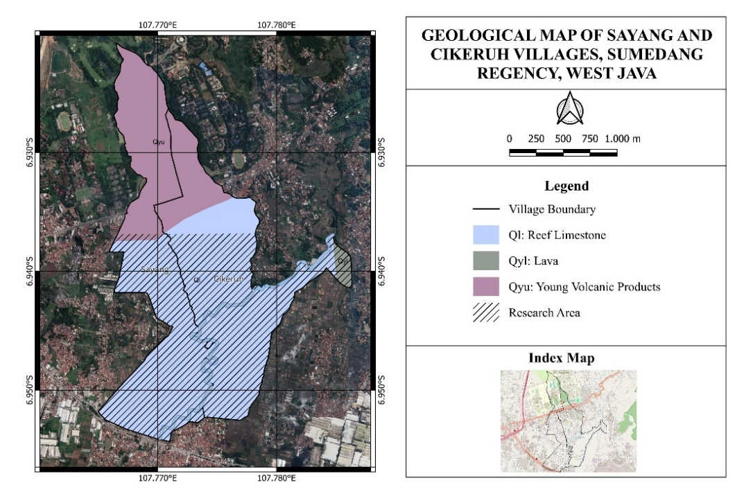
Figure 1. Geological map of Cikeruh and Sayang villages, Sumedang, West Java
2.2 Measurement of Physical and Chemical Parameters of Water
This study was conducted in Sayang and Cikeruh Villages, Jatinangor District, Sumedang Regency, West Java Province. The study focused on analyzing the physical and chemical parameters of water, including temperature, pH, EC, and TDS, in both well and river water. Water sampling was carried out at ten domestic wells distributed across both villages (SR1-SI10) and at nine sampling points along the Cikeruh River (SI1-SI9), which extends approximately 2.8 km, from the northern part of Cikeruh Village to the southern part of Sayang Village. The selection of sampling points considered representative spatial distribution, accessibility, and variations in surrounding environmental conditions. River water samples were collected at both upstream and downstream of the drainage channel to compare baseline water quality conditions with areas potentially influenced by anthropogenic activities.
All sampling points were mapped using satellite imagery, with reference to village administrative boundaries and river channels. The collected data were analyzed using descriptive and spatial approaches to evaluate water quality distribution patterns and their relationship with geological conditions, land use, and potential sources of pollution around the research site. The spatial distribution of well and river water sampling points is presented in Figure 2.
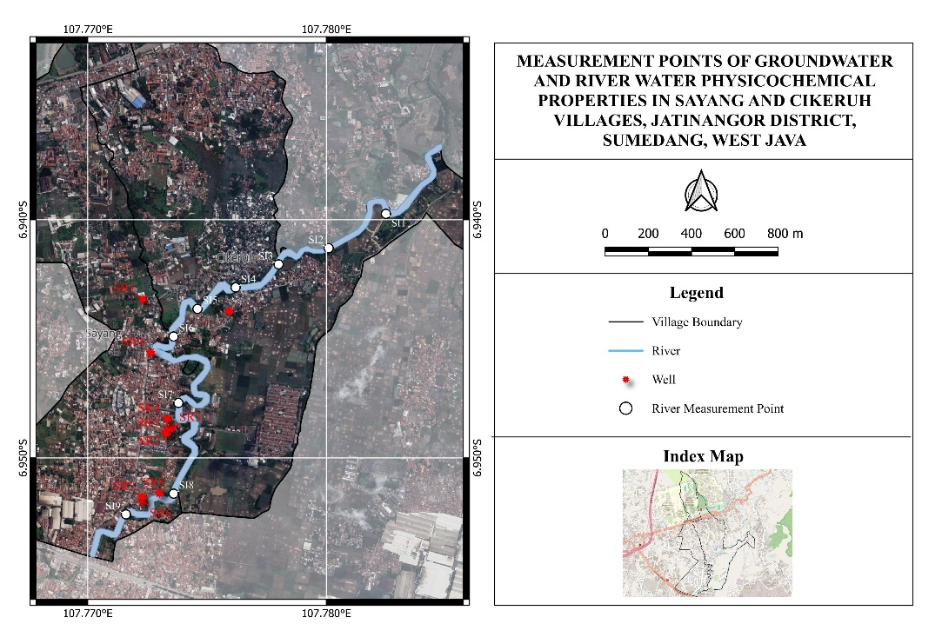
Figure 2. Map of Physical and Chemical Water Parameter Measurements in the Sayang and Cikeruh Villages, Jatinangor District, Sumedang, West Java

- RESULT AND DISCUSSION
3.1 Results and Analysis of Physical and Chemical Parameters of Well Water
Water quality measurements from ten domestic wells in Sayang and Cikeruh Villages indicate that most physicochemical parameters meet the standards of Permenkes No. 2 of 2023, several deviations were identified. Water temperature ranges from 28.2°C to 31°C, which remains within the normal range for tropical environmental conditions. The pH value ranges from 5.8 to 7.2, with two out of ten wells showing values below the minimum limit of 6.5, indicating acidic conditions. The EC values range from 370 to 560 µS/cm, with several wells exceeding the WHO recommended limit of 400 µS/cm, reflecting elevated dissolved ion concentrations. The TDS values also exceed the maximum allowable limit of 300 mg/L at several sampling points, suggesting potential contamination.
Based on the data presented in Table 1, spatial distribution maps of physicochemical parameters were generated (Figure 3) to examine spatial variations in well water quality. Higher well water temperatures are predominantly observed in the southern and western parts of the study area. Although these temperatures remain within acceptable limits, relatively higher temperatures may enhance chemical reactions and microbial activity in water. This spatial pattern is likely influenced by shallow well depths, direct exposure to sunlight, and proximity to paved surfaces or buildings. The distribution of pH values shows variation ranging from 5.8 to 7.2. The spatial distribution of pH values shows lower pH levels (5.8–6.14) in the northern part of the study area, which do not meet the national clean water quality standards and may increase corrosion risk. These acidic conditions may be associated with water–rock interactions, where geochemical weathering processes, including mineral dissolution and oxidation, control groundwater chemistry (Nordstrom, 2011). This interpretation is consistent with the geological characteristics of the Jatinangor area, which are dominated by volcanic materials that can influence groundwater composition through weathering processes (Suganda et al., 2021). In addition, the presence of organic matter surrounding the wells may further contribute to the observed acidity. In contrast, wells in the southern part of the study area exhibit neutral to slightly alkaline pH values (7.0–7.2), indicating better water quality conditions in these areas.

Table 1. Results of Physicochemical Parameter Measurements of Well Water in Sayang Village and Cikeruh Village
point | properties
point | temp (°C) | pH | EC (µS/cm) | TDS (mg/L)
SR1 | 29.0 | 5.9 | 430.0 | 306.0
SR2 | 28.2 | 6.2 | 520.0 | 378.0
SR3 | 28.3 | 6.9 | 370.0 | 266.0
SR4 | 29.2 | 6.4 | 560.0 | 401.0
SR5 | 29.7 | 6.5 | 420.0 | 304.0
SR6 | 31.0 | 7.2 | 480.0 | 346.0
SR7 | 30.0 | 7.2 | 440.0 | 315.0
SR8 | 30.0 | 6.7 | 390.0 | 284.0
SR9 | 29.8 | 7.0 | 460.0 | 329.0
SR10 | 29.2 | 5.8 | 370.0 | 269.0

The EC values range from 370 to 560 µS/cm, with higher values predominantly observed in the southern part of the study area. Several sampling points exceed the WHO recommended threshold of 400 µS/cm, indicating elevated dissolved ionic concentrations. Meanwhile, TDS values range from 266 to 401 mg/L, with most sampling points exceeding the maximum allowable limit of 300 mg/L according to the Indonesian Ministry of Health Regulation (Permenkes). Elevated EC and TDS values indicate an increased accumulation of dissolved substances, which are likely derived from domestic wastewater, dense residential activities, or local mineral dissolution processes. The consistent spatial relationship between EC and TDS further suggests that variations in dissolved constituents are primarily controlled by inorganic inputs associated with anthropogenic activities.
Overall, the southern part exhibits relatively higher water temperatures, more stable pH conditions, and higher EC and TDS values compared to the northern region. This spatial pattern suggests that well water quality in the southern region is more strongly influenced by human activities around the Cikeruh River flow. Therefore, this area requires continuous monitoring and sustainable groundwater resource management to prevent further degradation of water quality. To further examine the relationships among physicochemical parameters and identify dominant factors influencing well water quality, multivariate statistical analysis was performed using correlation-based Principal Component Analysis (PCA) and cluster analysis, as illustrated in Figure 4.

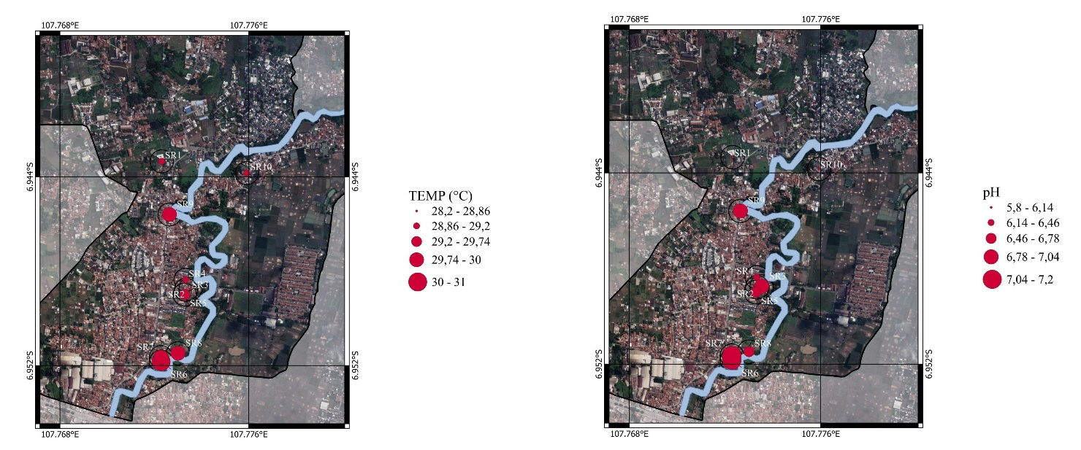
(a)
(b)

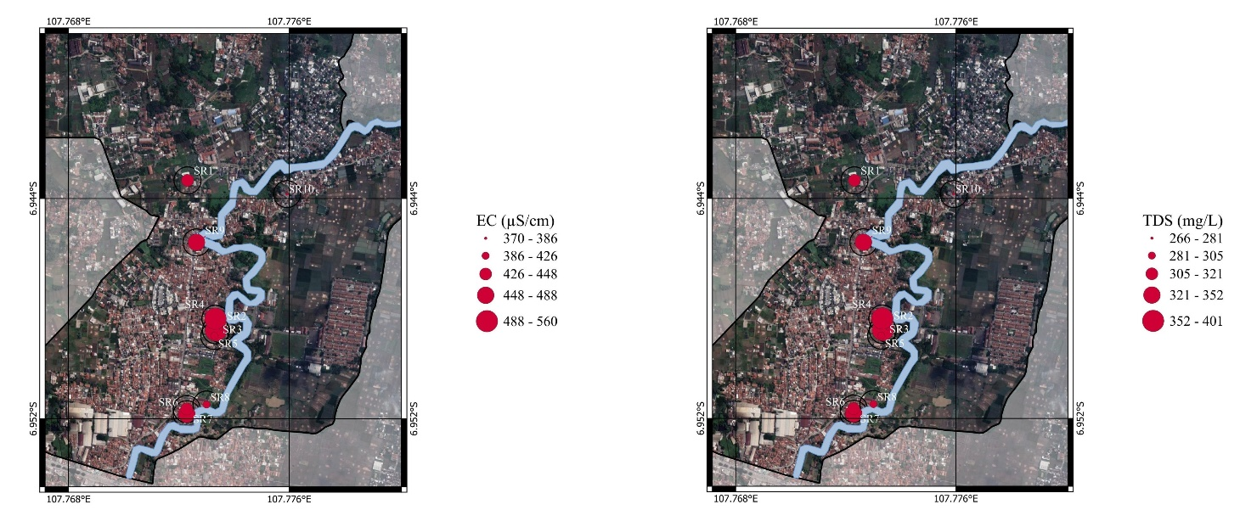
(d)
(c)

Figure 3. Spatial distribution maps of well water physicochemical parameters in Sayang and Cikeruh Villages: (a) temperature; (b) pH; (c) EC; and (d) TDS

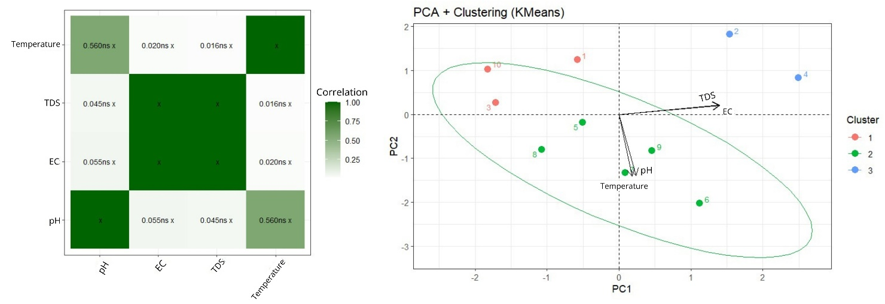
(a)
(b)

Figure 4. Multivariate analysis of well water physicochemical parameters: (a) Correlation heatmap; (b) PCA with K-means clustering of well sampling points

Multivariate analysis of well water physicochemical parameters (Figure 4) reveals clear relationships among the measured variables. The correlation heatmap (Figure 4a) indicates a strong positive relationship between EC and TDS, confirming that higher EC corresponds to higher concentrations of TDS in well water. In contrast, correlations among the other parameters are weak and statistically insignificant, suggesting limited direct interactions between temperature, pH, and the dissolved ion content. The PCA with K-means clustering (Figure 4b) further supports these findings. The first principal component (PC1) is primarily influenced by EC and TDS, as indicated by their similar vector directions, highlighting their dominant role in explaining variability in well water quality. Meanwhile, temperature and pH are more strongly associated with the second principal component (PC2), indicating that their contribution to overall variation is secondary compared to EC and TDS. Cluster analysis classifies the well sampling points into three distinct groups based on similarities in physicochemical characteristics. These clusters reflect spatial variations in well conditions, potentially influenced by differences in surrounding land use and local anthropogenic activities. Overall, the combined correlation, PCA, and clustering results emphasize the importance of EC and TDS as key indicators of well water quality and support their application in monitoring spatial variations in water conditions in Sayang and Cikeruh Villages.

3.2 Results and Analysis of Physicochemical Parameters of River Water
The results of physicochemical measurements indicate that water quality in the Cikeruh River generally meets applicable water quality standards. River water temperatures range from 27°C to 29.7°C, consistent with ambient conditions in tropical river environments. The pH values range from 6.9 to 7.3, indicating neutral conditions and compliance with regulatory limits. The measured EC values range from 80 to 120 µS/cm, while TDS values range from 66 to 80 mg/L, both of which remain below the recommended thresholds (<400 µS/cm for EC and <300 mg/L for TDS). Slight increases in EC and TDS values are observed at several sampling points located near potential sources of anthropogenic input. However, these variations do not exceed established thresholds, indicating that, overall, the water quality of the Cikeruh River remains within acceptable limits during the observation period.

Table 2. Results of Physicochemical Parameter Measurements of the Cikeruh River Water
point | properties
point | temp (°C) | pH | EC (µS/cm) | TDS (mg/L)
1 | 29.3 | 7.0 | 80.0 | 66.0
2 | 28.3 | 7.2 | 120.0 | 80.0
3 | 28.2 | 7.1 | 90.0 | 74.0
4 | 28.8 | 7.1 | 90.0 | 74.5
5 | 28.1 | 7.1 | 90.0 | 76.0
6 | 29.7 | 6.9 | 100.0 | 77.0
7 | 27.5 | 7.1 | 100.0 | 77.5
8 | 27.3 | 7.0 | 110.0 | 79.0
9 | 27.0 | 7.0 | 120.0 | 80.0

The data presented in Table 2 were used to generate spatial distribution maps for each parameter along the river section in Sayang and Cikeruh Village (Figure 5). The highest temperature was recorded at point 6 (29.7°C), while the lowest was observed at point 9 (27°C). Spatially, temperature generally decreases toward the downstream section, although a localized increase is observed in the middle segment. This variation is likely associated with differences in solar radiation exposure, where open river segments receive greater heat input, while shaded areas promote natural cooling. The pH values showing a relatively stable and near-neutral conditions. Slightly higher values occur at point 2 and point 8. The spatial distribution suggests that acidity levels remain relatively uniform along the flow path. The highest EC values observed at point 2 and point 9 (120 µS/cm). A decreasing trend is evident in the middle section, followed by an increase downstream. A similar pattern is observed for total dissolved solids (TDS) and exhibit maximum values at the same locations. The comparable spatial trends of EC and TDS indicate a strong relationship between these parameters, as both reflect dissolved ionic concentrations in the water.
Overall, the spatial distribution analysis indicates that the water quality of the Cikeruh River remains within permissible limits based on the measured physicochemical parameters. Although spatial variations in temperature, pH, EC, and TDS are observed along the river, all physicochemical parameters values remain below the threshold limits established by the WHO and the Indonesian Ministry of Health Regulation (Permenkes). However, the increasing trend of EC and TDS in the downstream area should be carefully monitored, as it may serve as an early indicator of anthropogenic pressure from domestic activities and land-use practices surrounding the river. Continuous monitoring is therefore recommended to prevent further degradation of water quality.

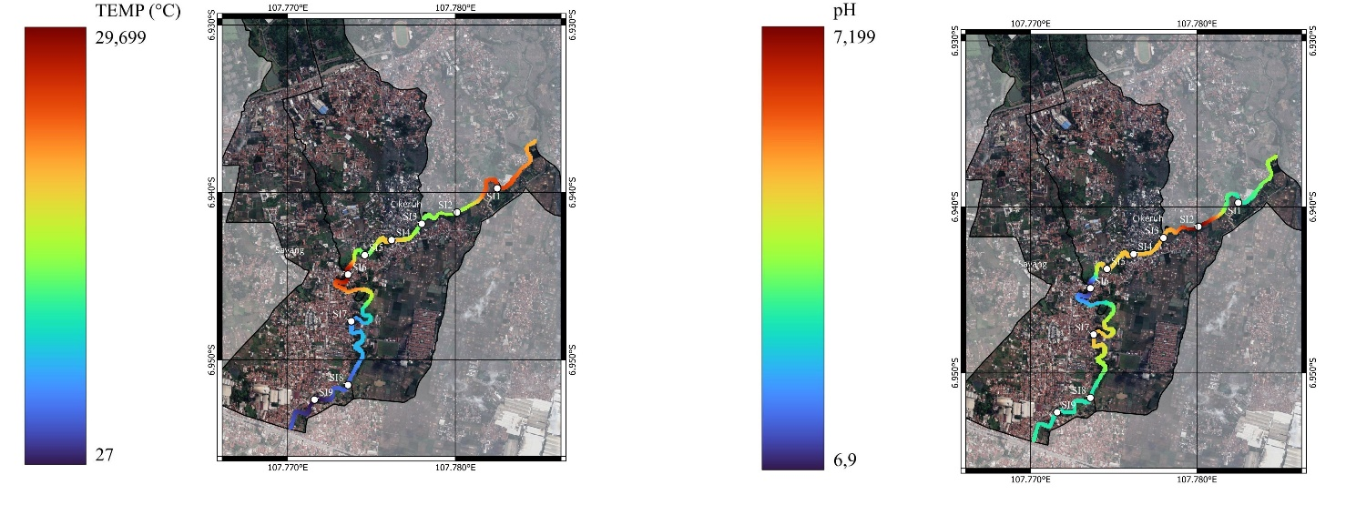
(b)
(a)

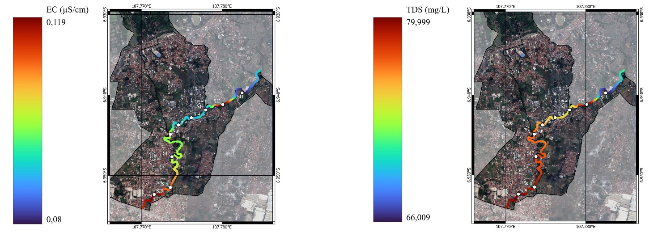
(d)
(c)

Figure 5. Spatial distribution maps of river water physicochemical parameters in Sayang and Cikeruh Villages: (a) temperature; (b) pH; (c) EC; and (d) TDS

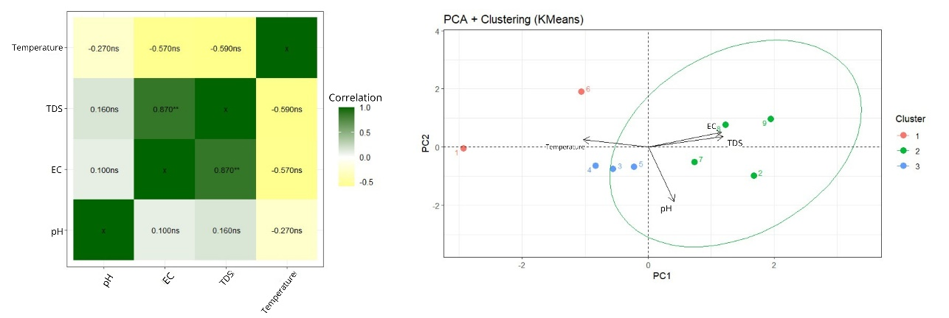
(b)
(a)

Figure 6. Multivariate analysis of well water physicochemical parameters: (a) Correlation heatmap; (b) PCA with K-means clustering of river sampling points

Multivariate analysis of the Cikeruh River water physicochemical parameters (Figure 6) reveals clear interrelationships among the variables. The correlation heatmap (Figure 6a) shows a very strong and statistically significant positive correlation between EC and TDS (r = 0.87, p < 0.01), confirming that dissolved ionic content is consistently represented by these two parameters. In contrast, temperature exhibits moderate negative correlations with EC (r = −0.57) and TDS (r = −0.59), indicating that higher temperatures tend to be associated with lower dissolved ion concentrations along the river. Meanwhile, pH shows weak and statistically insignificant correlations with the other parameters (r < 0.2), suggesting that it varies relatively independently within the river system.
The PCA biplot combined with K-means clustering (Figure 6b) further supports these findings. The first principal component (PC1) is primarily influenced by EC and TDS, as indicated by their parallel vector orientations, whereas temperature is oriented in the opposite direction, reflecting its negative relationship with these parameters. The pH vector appears relatively independent, confirming its weak association with the other variables. The clustering results identify three main groups of sampling points. Cluster 1 (points 1 and 6) occupies a distinct position, indicating localized conditions. Cluster 2 (points 2, 7, 8, and 9) is associated with higher EC and TDS values, suggesting greater dissolved ion concentrations, particularly in certain river sections. Meanwhile, Cluster 3 (points 3, 4, and 5) is located closer to the origin, representing relatively balanced physicochemical characteristics.

- CONCLUSION
Based on the research results, the objective of mapping the physicochemical parameters of well water and river water in Sayang and Cikeruh Villages has been achieved. The analysis shows that well water is more vulnerable to quality degradation, as indicated by low pH values and elevated EC and TDS levels that exceed quality standards, while river water remains within a safe category despite a tendency toward increased dissolved substance concentrations in downstream areas. These findings are consistent with the research expectations outlined in the introduction, namely that anthropogenic activities exert significant pressure on water quality in the study area. Future research may focus on long-term water quality monitoring, integration with more detailed hydrological and geological data, and the application of simple treatment technologies to reduce pollution impacts. Therefore, the results of this study can serve as a basis for sustainable water resource management and support efforts to mitigate water quality degradation in the Jatinangor area.

REFERENCES
García-Ávila, F., Huanga-Huanga, E., Méndez-Valladares, V., Peñaloza-Zhispón, U., Valdiviezo-Gonzales, L., & Sánchez-Cordero, E. (2025). Exploring groundwater quality through key parameters and management tools for its conservation and recovery. Environmental and Sustainability Indicators, 27(April). https://doi.org/10.1016/j.indic.2025.100767
Gautam, V. K., Kothari, M., Al-Ramadan, B., Singh, P. K., Upadhyay, H., Pande, C. B., Alshehri, F., & Yaseen, Z. M. (2024). Groundwater quality characterization using an integrated water quality index and multivariate statistical techniques. PLoS ONE, 19(2 February), 1–23. https://doi.org/10.1371/journal.pone.0294533
Gholizadeh, M. H., Melesse, A. M., & Reddi, L. (2016). A comprehensive review on water quality parameters estimation using remote sensing techniques. Sensors (Switzerland), 16(8). https://doi.org/10.3390/s16081298
Hadian, M. S. D., Azy, F. N., Krismadiyanti, I., Arfani, D. L., Sofyan, E. T., & Prayogi, T. E. (2015). Groundwater Quality Assessment for Suitable Drinking and Agricultural Irrigation Using Physico-Chemical Water Analysis in the Rancaekek-Jatinangor District, West Java, Indonesia Mohamad. International Conference on Environmental Science and Technology, 84. https://doi.org/10.7763/IPCBEE. 2015. V84. 10
Hamidah, W., & Cindramawa, C. (2020). Analysis of pH, total dissolved solid (TDS), and Mn levels in well water in Cirebon Regency. Indonesian Journal of Chemical Research, 5(1), 8–15.
Hanifah, S. D., Hendrayani, R., Carrisa, R., Rizki, M. I., Rohman, M. A., Hutabalian, M. A., Rahman, J. S., Sihombing, F. R., Ramadhan, F., Ramadan, A. Z., Nugraha, A., Kirana, K. H., & Fitriani, D. (2024). Mapping of pH, EC, and TDS Parameters to Identify Water Quality in Situ Cisanti. Jurnal Phi Jurnal Pendidikan Fisika Dan Fisika Terapan, 10(1), 91. https://doi.org/10.22373/p-jpft.v10i1.22175
Kementerian Kesehatan. (2023). Permenkes No. 2 Tahun 2023. Kemenkes Republik Indonesia, 55, 1–175.
Maria, R., Rusydi, A. F., Marganingrum, D., Damayanti, R., Nurohman, H., Lestiana, H., Shoedarto, R. M., Mulyono, A., Rahayudin, Y., Setiawan, T., Iskandarsyah, T. Y. W. M., Suganda, B. R., & Hendarmawan, H. (2024). Use of the Groundwater Quality Index, Multivariate statistics and Hydrogeochemistry for Groundwater Assessment in the Malabar Volcanic Area, Indonesia. Rudarsko Geolosko Naftni Zbornik, 39(5), 41–62. https://doi.org/10.17794/rgn.2024.5.3
Meride, Y., & Ayenew, B. (2016). Drinking water quality assessment and its effects on residents health in Wondo genet campus, Ethiopia. Environmental Systems Research, 5(1), 1–7. https://doi.org/10.1186/s40068-016-0053-6
Muniz, D. H. F., & Oliveira-Filho, E. C. (2023). Multivariate Statistical Analysis for Water Quality Assessment: A Review of Research Published between 2001 and 2020. Hydrology, 10(10). https://doi.org/10.3390/hydrology10100196
Nanda, M., Purba, A. F. H., Gultom, K., Sari, K. S., Muthmainah, N., & Muthmainah, N. (2023). Analisis parameter fisik (kekeruhan, Bau, Rasa) dan uji kandungan besi (Fe) pada sumur gali dan sumur bor di kkelurahan Bantan Kecamatan Medan Tembung Program studi Ilmu Kesehatan Masyarakat Universitas Islam Negeri Sumatera Utara. JURNAL KESEHATAN TAMBUSAI, 4(September), 2993–2997.
Nordstrom, D. K. (2011). Hydrogeochemical processes governing the origin, transport and fate of major and trace elements from mine wastes and mineralized rock to surface waters. Applied Geochemistry, 26(11), 1777–1791. https://doi.org/10.1016/j.apgeochem.2011.06.002
Suganda, B. R., Yusuf, W., Barkah, M. N., Sunarie, C. Y., & Hadian, M. S. D. (2021). Shallow Aquifer Groundwater Facies At Multiple Landuse Sites In Manglayang Volcanic Area, Jatinangor And Surroundings, Indonesia. Journal of Geoscience, Engineering, Environment, and Technology, 6(2), 120–126. https://doi.org/10.25299/jgeet.2021.6.2.3315
Trisnadiansyah, M. R., Listiawan, Y., Barkah, M. N., Sukiyah, E., & Hadian, M. S. D. (2022). Karakteristik fisika air tanah dan air permukaan serta hubungannya dengan kondisi geologi di lereng selatan Gunung Manglayang, Sumedang, Jawa Barat. Jurnal Pendidikan Geografi, 27(1), 88–101. https://doi.org/10.17977/um017v27i12022p88-101
Ullah, S., Javed, M. W., Rasheed, S. B., Jamal, Q., & Aziz, F. (2014). Assessment of groundwater quality of district Dir Lower Pakistan. International Journal of Biosciences (IJB), 6655, 248–255. https://doi.org/10.12692/ijb/4.8.248-255
Xie, M., Zhang, X., Jing, Y., Du, X., Zhang, Z., & Tan, C. (2024). Review on Research and Application of Enhanced In-Situ Bioremediation Agents for Organic Pollution Remediation in Groundwater. Water (Switzerland), 16(3). https://doi.org/10.3390/w16030456

