

PIONIR: JURNAL PENDIDIKAN
VOLUME 14 No 3 2025
P-ISSN 2339-2495/E-ISSN 2549-6611

THE DEVELOPMENT OF PANCASILA EDUCATION LEARNING MEDIA USING ARTICULATE STORYLINE WITH A CONTEXTUAL MODEL FOR FOURTH GRADE ELEMENTARY SCHOOL

Dellayla Ayu Az Zahra*
*Universitas Negeri Semarang, Indonesia
dellaylazahra25@students.unnes.ac.id

Eko Handoyo
Universitas Negeri Semarang, Indonesia
handoyo@mail.unnes.ac.id

Barokah Isdaryanti
Universitas Negeri Semarang, Indonesia
barokahisdaryanti@mail.unnes.ac.id

Received 06 October 2025, Accepted 25 December 2025, Published 30 December 2025

Abstract
Pancasila Education within the Merdeka Curriculum emphasizes the development of students’ critical thinking skills; however, instructional practices at the elementary school level continue to face challenges related to the analytical nature of the content, the potential for conceptual misconceptions particularly in distinguishing the second and fifth principles of Pancasila and the limited variation of learning media and integration of educational technology. Although previous studies have reported the effectiveness of Articulate Storyline and Contextual Teaching and Learning (CTL) when implemented separately, research that systematically integrates both approaches in the context of fourth-grade Pancasila Education, especially for Chapter 4 “Pancasila Dalam Diriku”, remains limited. This study aims to develop Pancasila Education learning media assisted by Articulate Storyline integrated with the CTL model and to examine its feasibility through expert validation involving content, media, and language specialists. The study employed a Research and Development (R&D) approach using the ADDIE model proposed by Branch, implemented up to the formative evaluation stage through expert validation, without conducting classroom implementation or student trials. The developed media, named Pandaku, incorporates trigger videos, interactive content, quizzes with automated feedback, contextual examples, summaries, and reflective activities. The validation results indicate that the media is highly feasible, achieving feasibility percentages of 95.38% (media expert), 96.92% (content expert), and 96% (language expert). Theoretically, this study contributes to the development of instructional design in Pancasila Education by offering a systematic integration of interactive digital media and CTL for value-based content that is prone to misconceptions. Practically, the developed media has the potential to enrich teachers’ instructional resources and support technology-based contextual learning in offline formats. Nevertheless, improvements in students’ critical thinking skills remain an anticipated potential that requires empirical verification through field implementation and effectiveness testing in future studies.
Keywords: Pancasila Education, Articulate Storyline, Contextual Model

Abstrak
Pembelajaran Pendidikan Pancasila dalam Kurikulum Merdeka menuntut penguatan kemampuan berpikir kritis, namun praktik di sekolah dasar masih dihadapkan pada materi yang bersifat analitis, potensi miskonsepsi khususnya pada pembedaan sila kedua dan sila kelima serta keterbatasan variasi media dan integrasi teknologi. Meskipun sejumlah penelitian menunjukkan efektivitas Articulate Storyline dan Contextual Teaching and Learning (CTL) secara terpisah, kajian yang mengintegrasikan keduanya secara sistematis pada konteks Pendidikan Pancasila kelas IV, khususnya materi Bab 4 “Pancasila dalam Diriku”, masih terbatas. Penelitian ini bertujuan untuk mengembangkan media pembelajaran Pendidikan Pancasila berbantuan Articulate Storyline yang terintegrasi dengan model CTL serta menguji tingkat kelayakannya melalui validasi ahli materi, media, dan bahasa. Penelitian menggunakan metode Research and Development (R&D) dengan model ADDIE versi Branch yang dilaksanakan hingga tahap evaluasi formatif melalui validasi ahli, tanpa tahap implementasi kepada siswa. Media “Pandaku” dirancang dengan fitur video pemantik, konten interaktif, kuis dengan umpan balik otomatis, contoh kontekstual, rangkuman, dan refleksi. Hasil validasi menunjukkan media berada pada kategori sangat layak dengan persentase 95,38% (media), 96,92% (materi), dan 96% (bahasa). Secara teoretis, penelitian ini berkontribusi pada pengembangan desain instruksional Pendidikan Pancasila melalui integrasi sistematis media digital interaktif dan CTL pada materi bernuansa nilai yang rawan miskonsepsi. Secara praktis, media ini berpotensi memperkaya perangkat ajar guru dan mendukung pembelajaran kontekstual berbasis teknologi dalam format luring. Namun demikian, peningkatan kemampuan berpikir kritis masih merupakan potensi yang memerlukan pengujian efektivitas melalui uji coba lapangan pada penelitian selanjutnya.
Kata Kunci: Pendidikan Pancasila, Articulate Storyline, Model Kontekstual

INTRODUCTION
Education is a fundamental process in developing individuals’ potential to become qualified and well characterized human beings. In Indonesia, education is directed toward educating the nation’s life and preparing future generations who are faithful, morally grounded, and competitive (Andi Sadriani et al., 2023; Zahra & Isdaryanti, 2024). Primary education plays a strategic role as it serves as the main foundation for character formation, basic literacy, and the development of students’ thinking skills at the ages of 7–13 years (Magdalena et al., 2020; Nugraha et al., 2023).
In line with the implementation of the Merdeka Curriculum, current educational goals are focused on fostering the Pancasila Student Profile, which encompasses dimensions of faith and piety, global diversity, mutual cooperation, independence, critical reasoning, and creativity. Pancasila Education functions as a primary vehicle for internalizing these values through meaningful and contextual learning experiences. Within the Merdeka Curriculum, Pancasila Education is structured into four core elements Pancasila, the Unitary State of the Republic of Indonesia (NKRI), Bhinneka Tunggal Ika, and the 1945 Constitution of the Republic of Indonesia which are interrelated and characterized by a relatively high level of conceptual complexity.
The complexity of Pancasila Education content, particularly within the Pancasila element, requires students to possess critical thinking skills. Learning is no longer oriented solely toward the acquisition of factual knowledge but also toward the ability to understand, analyze, and apply Pancasila values in real-life contexts (Kasminah, 2020). However, numerous studies indicate that Pancasila Education at the elementary school level continues to encounter several challenges, including students’ difficulties in comprehending analytical content, limited variation in learning media, and the dominance of teacher-centered instructional models (Angelina et al., 2023; Damayanti et al., 2022).
These challenges were also identified in Pancasila Education learning in Grade IV at SD Negeri Sampangan 02, Semarang City. Based on classroom observations and interviews with the principal and homeroom teacher, it was found that students’ learning outcomes had declined, particularly in the topic “Pancasila Dalam Diriku” Students experienced difficulties in understanding the historical formulation of Pancasila and distinguishing between the meanings of the second and fifth principles, which are often perceived as conceptually similar. This condition was further exacerbated by limited instructional media, low levels of technology integration, and the impact of post pandemic learning loss, which affected students’ active thinking habits and basic literacy skills.
To address these issues, instructional innovation is required through the integration of digital learning media and instructional models that facilitate active student engagement. Learning media function as tools for presenting content in a more concrete, engaging, and comprehensible manner, particularly when aligned with students’ characteristics and learning needs (Widyaningrum et al., 2022; Johan et al., 2025). The effectiveness of learning media is further enhanced when combined with instructional models that follow a systematic learning flow and emphasize the connection between content and students’ real-life contexts (Ahyar et al., 2021; Sung et al., 2022).
One digital learning medium with strong potential to support interactive learning is Articulate Storyline. This software enables the development of learning media incorporating videos, animations, illustrations, quizzes, and other interactive features that can be accessed across various digital devices (Agustina et al., 2021). Meanwhile, the Contextual Teaching and Learning (CTL) model emphasizes learning that connects academic content with real-life situations, thereby promoting active engagement, reflection, and problem-solving skills among students (Oktaviani et al., 2024).
Previous studies have demonstrated that the use of digital learning media and the application of contextual learning models contribute positively to improving the quality of learning in elementary schools. Articulate Storyline-assisted media have been shown to possess high feasibility and effectiveness in enhancing learning outcomes and students’ problem solving abilities (Daryanes et al., 2023; Zahra & Isdaryanti, 2024). Similarly, the implementation of the CTL model has been reported to improve learning outcomes in civics and Pancasila Education, particularly due to its emphasis on connecting content with students’ real life experiences (Soleha et al., 2023). These findings indicate the high urgency of integrating interactive digital media with context-based learning in value-oriented subjects.
Nevertheless, a review of previous studies reveals several limitations that open opportunities for further research. Putri and Reinita (2021) developed contextual-based Articulate Storyline media for integrated thematic learning in Grade IV, however their study did not specifically focus on Pancasila Education, which has distinctive analytical characteristics and a high potential for conceptual misconceptions. Zaini and Widodo (2022) developed Articulate Storyline media for Grade III civic education content, yet the CTL model was not explicitly positioned as a systematic instructional design framework. Furthermore, Oktaviani et al. (2024) demonstrated the effectiveness of CTL in Grade IV Pancasila Education but relied on concrete media rather than interactive digital media. Rifkiyani and Aeni (2025) developed Articulate Storyline media for Grade V Pancasila Education; however, their study did not emphasize explicit CTL integration and did not focus on the topic “Pancasila Dalam Diriku.
Based on this synthesis, a research gap can be identified: the development of Pancasila Education learning media assisted by Articulate Storyline and systematically integrated with the contextual learning model for fourth grade elementary students remains limited. Therefore, this study aims to develop Articulate Storyline based Pancasila Education learning media integrated with the CTL model for Chapter 4 “Pancasila Dalam Dirku” and to examine its feasibility based on expert evaluations in terms of content, media, and language. The novelty of this study lies in the systematic integration of interactive digital media and contextual learning to present analytically demanding Pancasila content through contextual activities oriented toward the development of Higher Order Thinking Skills (HOTS).

METHODS
This study employed a Research and Development (R&D) approach aimed at producing Pancasila Education learning media assisted by Articulate Storyline integrated with a contextual learning model, as well as examining its feasibility. The R&D approach was selected because it focuses on the systematic development of instructional products that are internally evaluated prior to broader implementation (Rayanto & Sugianti, 2020). The development model adopted was the ADDIE model proposed by Branch, which consists of five stages: Analyze, Design, Development, Implementation, and Evaluation. This model emphasizes the interrelationship among stages and continuous evaluation to ensure alignment between the developed product and instructional needs (Branch, 2009). However, the present study was limited to the evaluation stage in the form of expert feasibility validation and did not proceed to the implementation stage. Consequently, the developed media were not tested with students through either small-group or large-group trials. This limitation was intentionally applied because the study focused on product development and preliminary feasibility assessment prior to empirical implementation.
The analyze stage was conducted to identify instructional problems and the needs related to Pancasila Education learning media for fourth grade students. Data were collected through classroom observations, interviews with the fourth-grade teacher and the school principal, and needs analysis questionnaires administered to both teachers and students. The analysis focused on students’ characteristics, learning difficulties related to Chapter 4 “Pancasila Dalam Diriku,” and limitations in the use of interactive and contextual learning media. The results of this stage served as the basis for designing the learning media.
The design stage involved developing a media blueprint in the form of a storyboard that outlined learning objectives, content structure, navigation flow, interface design, types of interaction, and the integration of the contextual learning model syntax. At this stage, expert validation instruments were also developed in accordance with the assessment aspects, namely content, media, and language. The development stage entailed producing the learning media using Articulate Storyline software by utilizing its main features, including interactive slides, triggers, layers, timelines, embedded videos and animations, interactive quizzes, and automated feedback. The developed media, entitled “Pandaku,” were packaged in an offline digital format. Prior to validation, the media underwent an internal review to ensure consistency between the design specifications and the final product.
The evaluation stage was carried out through feasibility testing conducted by three experts: a content expert, a media expert, and a language expert. All experts were lecturers from the Elementary School Teacher Education (PGSD) program with expertise relevant to their respective domains. The content expert was a PGSD lecturer with a background in Pancasila Education or Civic Education and experience in instructional material development. The media expert was a PGSD lecturer specializing in the development of concrete and digital learning media. The language expert was a PGSD lecturer with a background in linguistics and expertise in the appropriate use of Indonesian language in accordance with standardized spelling conventions. Expert selection criteria included academic background relevance, teaching experience, and involvement in instructional material development.
The expert validation instruments consisted of Likert-scale questionnaires with a score range of 1–5. The content validation instrument assessed alignment with learning objectives, conceptual depth and accuracy, coherence and systematic presentation of content, relevance to students’ real-life contexts, and the potential of the content to foster critical thinking skills. The media validation instrument evaluated visual appearance, navigation, interactivity, usability, media compatibility, and alignment with instructional objectives. The language validation instrument assessed clarity and effectiveness of sentences, appropriateness of language to students’ cognitive development, grammatical accuracy, and the use of spelling and vocabulary in accordance with Indonesian language standards.
Research data were collected through observations, interviews, and questionnaires and were analyzed using descriptive qualitative and quantitative techniques. Descriptive qualitative analysis was used to describe the media development process and experts’ suggestions, while descriptive quantitative analysis was employed to determine the feasibility level of the media based on validation questionnaire results. The obtained scores were calculated using a percentage formula and interpreted according to predefined feasibility criteria. The results and feedback provided by the experts served as the basis for revising the media to ensure that the developed product met feasibility standards prior to subsequent instructional trials.

RESULTS AND DISCUSSION

Development of Learning Media with The ADDIE Model
This study employed a Research and Development (R&D) approach that resulted in the production of Pancasila Education learning media assisted by Articulate Storyline and integrated with a contextual learning model. The developed media cover the content of Chapter 4, “Pancasila Dalam Diriku” and are entitled Pandaku. The development process followed the ADDIE model proposed by Branch, which consists of the stages of Analyze, Design, Development, Implementation, and Evaluation. The ADDIE model was selected because it provides a systematic framework that integrates needs analysis, instructional design, product development, and continuous evaluation to ensure alignment between the developed product, instructional objectives, and learners’ characteristics (Branch, 2009; Molenda, 2015). In line with this, Hidayati et al. (2024) emphasize that the ADDIE model is effective for digital media development because it allows iterative refinement based on feedback obtained at each stage.
In this study, the scope of development was deliberately limited to the evaluation stage in the form of expert feasibility validation, without proceeding to implementation with students. This methodological limitation was intentionally applied because the research focus was directed toward product development and preliminary feasibility assessment at the conceptual and technical levels prior to empirical field testing. Consequently, the study does not examine the effectiveness of the media in improving students’ learning outcomes, but rather ensures that the product meets feasibility standards in terms of content, media design, and language. This approach is consistent with development research recommendations that position expert validation as a critical prerequisite before conducting effectiveness testing in real classroom settings (Plomp, 2013; van den Akker et al., 2010).
The analyze stage was conducted to identify instructional needs, student characteristics, and learning problems encountered in Pancasila Education. Data obtained from classroom observations, interviews with the classroom teacher and school principal, and needs analysis questionnaires indicated that fourth-grade students experienced difficulties with conceptually and analytically demanding content, particularly in distinguishing between the meanings of the second and fifth principles of Pancasila and in understanding the historical formulation of Pancasila. These findings are consistent with previous studies reporting that Pancasila Education learning is often constrained by limited conceptual depth and low levels of active student engagement (Kasminah, 2020; Angelina et al., 2023). In addition, limited availability of interactive learning media and the impact of post-pandemic learning loss further weakened students’ critical thinking skills and basic literacy (Kuhfeld et al., 2020).
The subsequent stage was the design stage, which involved planning the product based on the results of the analysis (Johan et al., 2025). At this stage, the latest version of Articulate Storyline software was utilized, and the learning media concept was developed in accordance with the needs of fourth-grade students and teachers at SD Negeri Sampangan 02. The media design was articulated in the form of a storyboard serving as a guideline for media development. The content “Pancasila Dalam Diriku” was selected due to its relatively high level of complexity and its potential to generate conceptual misconceptions if not presented systematically and contextually. The storyboard was designed to ensure coherence among learning objectives, content, interactive activities, and evaluation components. The media were developed based on a contextual learning model by positioning students’ real-life experiences as the starting point of learning. This approach aligns with contextual learning theory, which emphasizes that learning becomes more meaningful when students are able to connect new knowledge with their lived experiences (Johnson, 2002; Berns & Erickson, 2001). In addition, the systematic structure of the media was intended to reduce students’ cognitive load through staged content presentation and well-directed visual design (Sweller et al., 2019). The media structure includes an opening screen, student identification, user instructions, a main menu, two learning activities, quizzes, reflection, summaries, a glossary, references, and a developer profile. The storyboard developed at the design stage is presented as follows.

Table 1. Storyboard of Pandaku
Section | Description
Cover (Opening Screen) | Displays the learning material identity (chapter, topic, grade level, and subject) along with a Start button as the main entry point to the learning media.
Student Identification | A slide featuring an animated character that provides instructions for students to enter their personal or group identification before the learning activities begin.
User Instructions | Contains guidance on how to use the learning media and explanations of the navigation buttons employed throughout the learning process.
Main Menu | Consists of buttons for Learning Activity 1, Learning Activity 2, Summary, Reflection, Glossary, References, Audio Settings, Developer Profile, and Exit.
Learning Activity 1 | Includes learning objectives, instructional content, quizzes, and a mini-summary. The content begins with a triggering video, followed by the history of Pancasila formulation, key figures involved, and the meanings of the Pancasila principles in daily life contexts.
Learning Activity 2 | Begins with an apperception activity related to the previous lesson and includes learning objectives, content on attitudes and behaviors reflecting Pancasila values in social life, a mini-summary, and a reflection component.
Quiz Menu | Contains a true–false quiz consisting of five items. Students select their answers and receive scores and immediate feedback upon completion of the quiz.
Reflection Menu | Comprises three reflective questions addressing students’ learning experiences, newly acquired knowledge, and short written responses related to their conceptual understanding.
Summary Menu | Presents a concise summary of the materials covered in Learning Activity 1 and Learning Activity 2.
Glossary Menu | Provides a list of key terms used in the learning materials along with their definitions.
References Menu | Displays the sources and references utilized in the development of the learning materials.
Developer Profile Menu | Contains information about the media developers, including the researcher and academic supervisors.
Exit Menu | A button that allows users to end and close the learning media application.

After the design phase was completed, the study proceeded to the development stage. This stage involved producing the learning media based on the previously established design framework (Safitri et al., 2023). The development process began with the creation of media elements using the Canva application. The opening screen was designed with a high-contrast layout featuring the title of the learning material, the researcher’s name, a start button, and supporting illustrations.
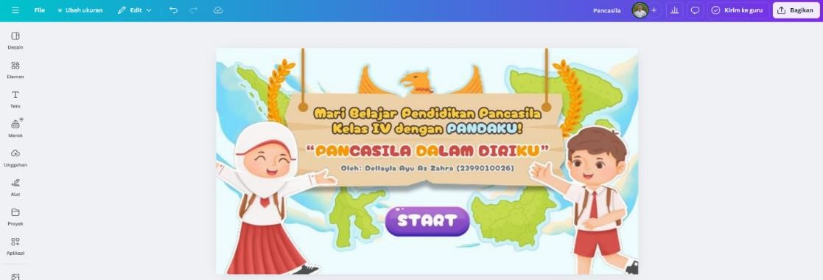
Figure 1. Creation of Elements on the Opening Page of the Learning Media (Source: Product Design Results)
At this stage, various features were developed and integrated into the learning media. The use of features such as introductory videos, initial guiding questions, clickable content, interactive quizzes, and automated feedback was intentionally designed not merely as visual variations, but as pedagogical strategies to foster active student engagement and promote critical thinking. The introductory videos and contextual narratives functioned as anchoring contexts to activate students’ prior knowledge and to support their understanding of the relevance of the learning material to everyday life, in accordance with the principles of contextual learning that emphasize the connection between content and learners’ real-world experiences (Hasnidar & Elihami, 2020). Interactive quizzes with immediate feedback supported effective formative assessment by enabling students to independently identify and correct misconceptions, while also serving as a means of reinforcing conceptual understanding and encouraging decision-making based on comprehension rather than rote memorization (Hattie & Timperley, 2007). In addition, the reflection menu was designed to promote students’ metacognitive processes through reflective questions addressing learning experiences, newly acquired knowledge, and the application of Pancasila values in daily life.
In the Pandaku learning media, the cover (opening screen) presents essential instructional information, including the chapter, topic, grade level, and subject area. The student identity slide features an animated character that provides instructions for students to enter their personal or group identification prior to commencing the learning activities.
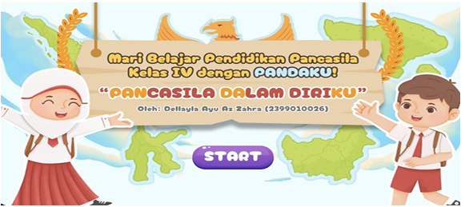
Figure 2. Cover of Pandaku


Figure 3. Student Identity Entry Page
Another component of the learning media is the main menu, which consists of Learning Activity 1, Learning Activity 2, Material Summary, Reflection, Glossary, References, Audio Settings, Developer Profile, User Guide, and an Exit button. Each learning activity includes clearly stated learning objectives, instructional content, quizzes, and a brief summary. Learning Activity 1 begins with a trigger video followed by guiding questions that students are required to answer based on the video content. Students’ responses are stored while the media is in use. The use of trigger videos and accompanying questions is intended to activate students’ prior knowledge and foster the development of critical thinking skills.
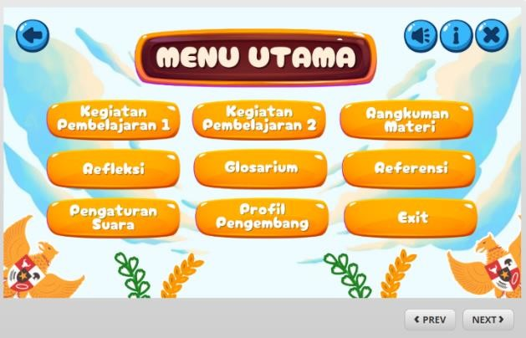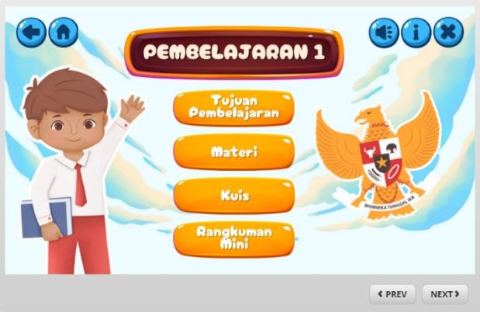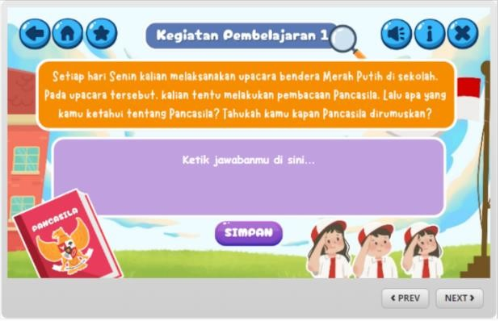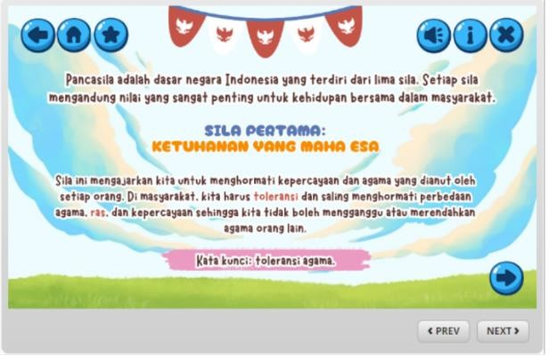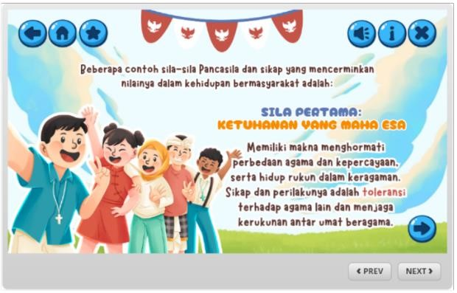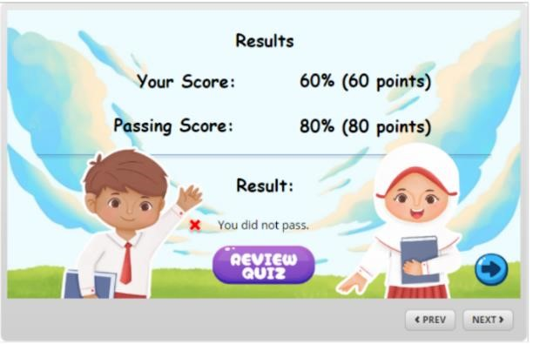

Figure 4. Main Menu and Learning Activities 1 and 2 (Source: Product Development Results)

In Learning Activity 1, two subtopics are presented: the historical formulation of Pancasila and the meaning of each Pancasila principle. The history of Pancasila’s formulation is delivered through clickable key dates, while the meaning of each principle is explained using concise keywords to facilitate students’ comprehension. Learning Activity 2 focuses on attitudes and behaviors that reflect Pancasila values in social life. The content begins with a dialog between characters, followed by analytical tasks that require students to identify behaviors aligned with Pancasila values. Each instructional component is supported by illustrations or animations to enhance understanding, capture students’ attention, and support memory retention and information processing (Dwiyanto et al., 2024). Contextual examples closely related to students’ everyday experiences are incorporated to make the content more accessible. In addition, the media includes “Did You Know?” sections that present interesting facts about Pancasila to broaden students’ knowledge.
Furthermore, the learning media incorporates a true and false quiz consisting of five statements. Students respond to each statement and receive immediate feedback through sound effects and reaction icons. At the end of the quiz, students can view their scores and access the answer key via the review quiz button. A reflection menu is provided to allow students to give feedback on their learning experiences, while the summary menu helps consolidate key concepts from the instructional materials.
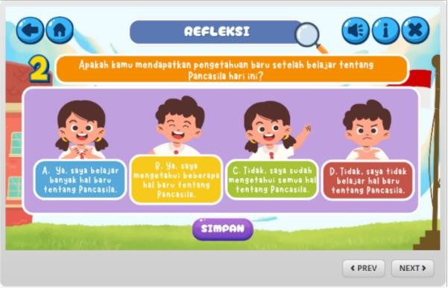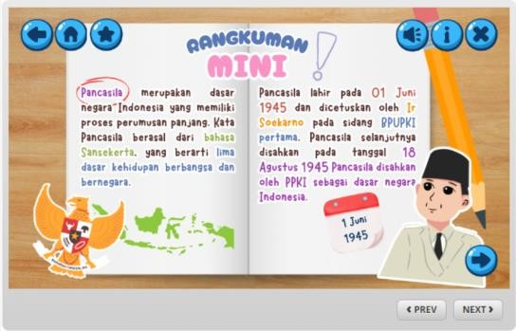
Figure 5. Reflection and Mini Summary (Source: Product Development Result)

The Pandaku learning media was packaged in an offline format (hyperlink-based and application based), allowing flexible use across various devices and school infrastructure conditions. This flexibility is particularly important given that unequal access to technology remains a significant challenge in elementary schools (OECD, 2021). These findings reinforce previous studies by Hidayati et al. (2022) and Agustina et al. (2021), which reported that Articulate Storyline is effective for developing interactive learning media that are easy to operate and adaptable to infrastructural limitations. The use of contextual examples and character based dialogues in Learning Activity 2 directly addresses students’ difficulties in connecting Pancasila concepts with social practices, thereby promoting more meaningful learning. This result supports the findings of Dwiyanto et al. (2024), who emphasized that visualization, illustrations, and real-life contexts can enhance conceptual understanding and memory retention among elementary school students.
In this study, the ADDIE development model was applied in a limited manner up to the evaluation stage. The implementation stage was not conducted, as the research focus was placed on product development and preliminary feasibility assessment prior to empirical classroom implementation. Consequently, the developed learning media were not tested with students, either in small group or large group trials. Following the analysis, design, and development stages, the research proceeded to the evaluation stage, which was conducted in a limited form through expert validation. The developed media were reviewed by content, media, and language experts using feasibility validation instruments that covered content accuracy, media design, and linguistic appropriateness.
This evaluation aimed to examine the conceptual and technical readiness of the product and to identify potential weaknesses and areas for improvement before classroom implementation. Positioning expert validation as a formative evaluation stage is consistent with research and development principles that emphasize the importance of internal evaluation prior to field testing (Tessmer, 1993). Accordingly, this study did not seek to examine the effectiveness of the media on students’ learning outcomes, but rather to ensure that the developed learning media met feasibility criteria as an instructional product suitable for further implementation in subsequent research.

Expert Evaluation Results of The Media
The Articulate Storyline-based learning media was evaluated through expert validation or feasibility testing. This evaluation covered aspects of content, media, and language, with experts acting as validators. The results provide an overview of the media's feasibility and validity before being tested with students in class. The evaluation includes scores, critiques, and suggestions. The media's feasibility was assessed using a Likert scale of 1-5, and the results were calculated using the following formula:

$P= \frac{f}{N }$ x 100
Keterangan:
P : Percentage
f : Obtained score
N : Total score

After calculating the percentage, the results were converted according to the following evaluation criteria.
Table 2. Evaluation Criteria Categories
Scale | Feasibility Criteria
86-100 % | Very Feasible
76-85 % | Feasible
60-75 % | Sufficiently Feasible
55-59 % | Not Feasible
≤ 54 % | Not Feasible at All

The results of the feasibility test by experts in the aspects of content, media, and language are presentased in the table below.

Table 3. Media Expert Validation Results
No | Assesment Indicators | Score
No | Assesment Indicators | 1 | 2 | 3 | 4 | 5
1 | Maintainable (easily managed and does not require special treatment). |  |  |  |  | ✓
2 | Usable (easy to operate or use). |  |  |  |  | ✓
3 | Compatible (downloadable and operable on various devices). |  |  |  | ✓
4 | Functional multimedia operations (clear user guide available). |  |  |  |  | ✓
5 | Reusable (parts or the entire media program can be reused or adapted for other learning media). |  |  |  | ✓
6 | Media content aligns with learning objective. |  |  |  |  | ✓
7 | Interactive learning media. |  |  |  |  | ✓
8 | Relevance of content in terms of context and current issues. |  |  |  |  | ✓
9 | Provides feedback. |  |  |  |  | ✓
10 | Clear navigation, with user instructions or buttons that are easy to follow. |  |  |  |  | ✓
11 | Audio components (narration, sound effects, and appropriate background music). |  |  |  |  | ✓
12 | Visual components (design layout, |  |  |  | ✓
13 | Appropriate use of animation, images, videos, or illustrations. |  |  |  |  | ✓
Total Score =  x 100
= 95.38% (Very Feasible)
Source: Data processed in 2025

The feasibility test results indicate that the Pandaku learning media achieved a very feasible category across all assessment aspects. Validation by the media expert yielded a feasibility percentage of 95.38%, indicating that the media demonstrates high visual quality, clear navigation, adequate interactivity, and cross-device compatibility. These findings support Mayer’s (2020) multimedia learning theory, which posits that well designed multimedia can enhance students’ attention and information processing. The results of the content expert validation are presented as follows.

Table 4. Material Expert Validation Results
No | Assesment Indicators | Score
No | Assesment Indicators | 1 | 2 | 3 | 4 | 5
1 | Alignment of content with learning outcomes and objectives. |  |  |  |  | ✓
2 | Depth of content in the Pancasila education lesson. |  |  |  |  | ✓
3 | Accuracy and precision of the concepts used in the learning media. |  |  |  | ✓
4 | Appropriateness of content to the characteristics of students. |  |  |  |  | ✓
5 | Relevance of the content to the students' real-life context. |  |  |  |  | ✓
6 | Correct presentation of the content concepts. |  |  |  |  | ✓
7 | Coherence among the presented subtopics. |  |  |  |  | ✓
8 | Interactivity and student engagement. |  |  |  |  | ✓
9 | Systematic and structured presentation of the content. |  |  |  |  | ✓
10 | Encouragement of critical thinking through the content presented. |  |  |  |  | ✓
11 | Appropriateness of the content with the animations and illustrations. |  |  |  |  | ✓
12 | Correct use of language according to the Enhanced Spelling System (EYD) Edition 5. |  |  |  |  | ✓
13 | Selection of appropriate vocabulary. |  |  |  |  | ✓
Total Score =  x 100
= 96.92% (Very Feasible)
Source: Data processed in 2025

Validation by the content expert resulted in a feasibility percentage of 96.92%, which falls into the very feasible category. This score indicates that the instructional content is well aligned with the learning objectives, conceptually accurate, systematically organized, and relevant to students’ real life contexts. The expert’s suggestion to refine key terms in the explanations of the second and fifth principles of Pancasila reflects careful attention to potential conceptual misconceptions, which constitute a critical issue in Pancasila Education learning (Nucci et al., 2014). It should be emphasized that the 96.92% score represents the final validated value to avoid ambiguity with other non-applicable figures. The results of the language expert evaluation are presented as follows.

Table 5. Language Expert Validation Results
No | Assesment Indicators | Score
No | Assesment Indicators | 1 | 2 | 3 | 4 | 5
1 | Suitability with students’ cognitive development. |  |  |  |  | ✓
2 | Accuracy in sentence structure. |  |  |  |  | ✓
3 | Sentence effectiveness. |  |  |  | ✓
4 | Relevance of illustrations to the message content. |  |  |  |  | ✓
5 | Encouragement of students’ critical thinking. |  |  |  |  | ✓
6 | Coherence between chapters, subchapters, and paragraphs. |  |  |  |  | ✓
7 | Grammatical accuracy. |  |  |  |  | ✓
8 | Correct spelling based on the Enhanced Spelling System (EYD) 5th Edition. |  |  |  |  | ✓
9 | Consistency in the use of language rules. |  |  |  |  | ✓
10 | Consistency in the use of symbols or icons. |  |  |  |  | ✓
Total Score =  x 100
= 96 % (Very Feasible)
Source: Data processed in 2025

The language expert validation yielded a feasibility score of 96%, categorized as very feasible, indicating that the language used in the learning media is appropriate for students’ cognitive development and complies with prevailing linguistic and grammatical standards. Linguistic clarity is essential in value-based learning contexts, as it facilitates accurate comprehension of moral and conceptual content (Tomlinson, 2013).
Overall, the evaluations conducted by the content, media, and language experts demonstrate that the developed learning media is highly feasible for further use at the preliminary stage. The content expert assessment resulted in a score of 96.92%, suggesting that the instructional material is conceptually accurate, systematically organized, and aligned with the objectives of Pancasila Education for fourth-grade students. The media expert validation produced a score of 95.38%, reflecting adequate visual quality, interactivity, navigation, and technical functionality. In addition, the language expert score of 96% confirms that the linguistic elements of the media are suitable for elementary school learners and conform to standard language conventions.
Taken together, these findings indicate that the Pandaku learning media meets the essential feasibility criteria to function as an instructional resource in Pancasila Education at the elementary school level. The scientific contribution of this study lies in the systematic integration of interactive digital media using Articulate Storyline with the Contextual Teaching and Learning (CTL) approach, specifically designed for value-oriented and conceptually demanding content. Unlike previous studies that tended to examine digital media development or CTL implementation separately, this study offers an integrative instructional design framework tailored to fourth-grade Pancasila Education.
Nevertheless, it is important to emphasize that the potential contribution of the media to enhancing students’ critical thinking skills remains theoretical and anticipatory, as this study was limited to expert-based formative evaluation. Empirical testing through classroom implementation and effectiveness studies is therefore required to substantiate these potential learning outcomes in future research.

CONCLUSION
This study aimed to (1) develop a Pancasila Education learning medium assisted by Articulate Storyline and integrated with the Contextual Teaching and Learning (CTL) model for Chapter 4, “Pancasila Dalam Diriku”, for fourth grade elementary school students, and (2) examine the feasibility of the developed media based on evaluations by content, media, and language experts. Based on the findings, two main conclusions can be drawn.
First, the Pandaku learning media was successfully developed through the Analyze, Design, Development, Evaluation stages of the ADDIE model (Branch version), with its design grounded in the actual learning needs identified at SD Negeri Sampangan 02. The development process was intentionally directed to address key instructional challenges, including students’ difficulties in understanding conceptually and analytically demanding content (such as the history of Pancasila formulation and the distinction between the second and fifth principles), limited variation in learning media, and low levels of active student engagement. These needs were addressed through the integration of instructional features such as introductory videos and guiding questions to activate prior knowledge, interactive (clickable) content to present material in a structured and gradual manner, contextual examples and dialogues linking concepts to real-life experiences, true and false quizzes with immediate feedback to reinforce understanding and identify misconceptions, as well as summary and reflection components to support conceptual consolidation and metacognitive processes. Accordingly, this study substantively addresses the research gap identified in the introduction, namely the limited availability of fourth-grade Pancasila Education learning media that systematically integrate Articulate Storyline and the CTL approach, particularly for the topic “Pancasila Dalam Diriku”, which is prone to misconceptions and requires analytical thinking activities.
Second, the feasibility evaluation results indicate that the Pandaku media falls within the very feasible category across all assessed aspects, with scores of 95.38% from the media expert, 96.92% from the content expert, and 96% from the language expert. These findings suggest that the media meets feasibility standards in terms of visual quality and navigation, interactivity and usability, conceptual accuracy and systematic presentation of content, as well as language appropriateness for students’ cognitive development. However, it must be emphasized that this study was limited to formative evaluation through expert validation and did not proceed to the implementation stage. Consequently, the learning media has not yet been tested with students through either small scale or large scale trials. Therefore, the conclusions of this study do not extend to empirical evidence regarding the effectiveness of the media in improving learning outcomes or critical thinking skills, but are confined to establishing product feasibility as a prerequisite for subsequent field testing.
From a theoretical perspective, this study contributes to the literature on value-based learning media development by demonstrating that interactive digital media and the CTL approach can be systematically integrated into a unified instructional design that connects value oriented concepts with students’ reallife contexts, thereby holding potential to support meaningful learning and higher-order thinking skill development. From a practical perspective, the Pandaku media may be utilized by fourth grade teachers as an alternative instructional resource to diversify learning media, enhance student engagement, and reduce misconceptions related to the topic “Pancasila in Me”. In addition, the availability of the media in an offline format makes it particularly suitable for schools with limited internet access.

RECOMMENDATIONS
Future research should extend this study by conducting small and large scale field trials to examine the usability, student responses, and empirical effectiveness of the developed media in improving learning outcomes and critical thinking skills through quasi-experimental or experimental designs. Content refinement is also recommended, particularly by strengthening key concepts and providing clearer contextual distinctions between the second and fifth principles of Pancasila to reduce potential misconceptions. In addition, the assessment component should be expanded to include more varied formats such as reasoned multiple-choice items, short case analyses, or situational tasks to better capture higher-order thinking skills. For practical implementation, teachers and schools are advised to provide brief orientation sessions and appropriate technical preparation to ensure the optimal integration of introductory videos, feedback, and reflection activities within the Contextual Teaching and Learning (CTL) framework.

REFERENCES
Agustina, Agustina, R., Putra, Z. H., & Alim, J. A. (2021). Pengembangan media pembelajaran interaktif berbasis Articulate Storyline pada pembelajaran di sekolah dasar. Jurnal Pendidikan Dasar, 12(2), 123–133.
Ahyar, H., Andriani, H., & Hasanah, U. (2021). Model pembelajaran dan sintaksnya dalam pembelajaran abad ke-21. Jurnal Pendidikan dan Pembelajaran, 8(1), 45–55.
Akker, J. van den, Gravemeijer, K., McKenney, S., & Nieveen, N. (2010). Educational design research. Routledge.
Andi Sadriani, A., Rahman, A., & Kurniawan, D. (2023). Pendidikan karakter dalam membangun generasi berdaya saing di abad ke-21. Jurnal Ilmu Pendidikan, 5(2), 110–120.
Angelina, D., Suyitno, I., & Prasetyo, Z. K. (2023). Tantangan pembelajaran Pendidikan Pancasila di sekolah dasar. Jurnal Civics: Media Kajian Kewarganegaraan, 20(2), 185–197.
Berns, R. G., & Erickson, P. M. (2001). Contextual teaching and learning: Preparing students for the new economy. The Highlight Zone, 5(2), 1–8.
Branch, R. M. (2009). Instructional design: The ADDIE approach. Springer.
Damayanti, R., Sari, P. N., & Wahyuni, S. (2022). Analisis sumber belajar Pendidikan Pancasila di sekolah dasar. Jurnal Pendidikan Kewarganegaraan, 12(1), 33–41.
Daryanes, F., Darmadi, D., Fikri, K., Sayuti, I., Rusandi, M. A., & Situmorang, D. D. B. (2023). The development of Articulate Storyline interactive learning media based on case methods to train students’ problem-solving ability. Heliyon, 9(4), e15082.
Dwiyanto, K., Suyanto, E., & Prasetyo, Z. K. (2024). Visualisasi dan konteks nyata dalam pembelajaran sekolah dasar. Jurnal Teknologi Pendidikan, 26(1), 67–78.
Hasnidar, & Elihami. (2020). Contextual teaching and learning approach in improving students’ learning motivation. Journal of Education and Learning, 14(1), 48–54.
Hattie, J., & Timperley, H. (2007). The power of feedback. Review of Educational Research, 77(1), 81–112.
Hidayati, N., Putra, Z. H., & Alim, J. A. (2022). Development of interactive multimedia using Articulate Storyline to support elementary learning. Jurnal Pendidikan Dasar, 13(2), 137–147.
Hidayati, N., Alim, J. A., & Putra, Z. H. (2024). Pengembangan media pembelajaran berbasis ADDIE untuk sekolah dasar. Jurnal Penelitian dan Evaluasi Pendidikan, 28(1), 55–67.
Johan, R., Fitriani, D., & Rahmawati, Y. (2025). Pemilihan media pembelajaran digital berdasarkan kebutuhan peserta didik sekolah dasar. Jurnal Pendidikan Dasar Nusantara, 10(1), 15–26.
Johnson, E. B. (2002). Contextual teaching and learning. Corwin Press.
Kasminah. (2020). Pengembangan kemampuan berpikir kritis dalam pembelajaran Pendidikan Kewarganegaraan. Jurnal Pendidikan Kewarganegaraan, 10(2), 95–103.
Kuhfeld, M., Soland, J., Tarasawa, B., Johnson, A., Ruzek, E., & Liu, J. (2020). Projecting the potential impact of COVID-19 school closures on academic achievement. Educational Researcher, 49(8), 549–565.
Magdalena, I., Fauziah, N., & Amalia, S. (2020). Peran pendidikan dasar dalam pembentukan karakter anak. Jurnal Pendidikan Guru Sekolah Dasar, 5(1), 1–9.
Mayer, R. E. (2020). Multimedia learning (3rd ed.). Cambridge University Press.
Molenda, M. (2015). In search of the elusive ADDIE model. Performance Improvement, 54(2), 40–42.
Nucci, L., Narvaez, D., & Krettenauer, T. (2014). Handbook of moral and character education (2nd ed.). Routledge.
OECD. (2021). The state of school education: One year into the COVID pandemic. OECD Publishing.
Oktaviani, Z. N., Susiani, T. S., & Wahyudi. (2024). Penerapan model Contextual Teaching and Learning pada pembelajaran Pendidikan Pancasila sekolah dasar. Kalam Cendekia, 12(3), 1–9.
Plomp, T. (2013). Educational design research: An introduction. In T. Plomp & N. Nieveen (Eds.), Educational design research (pp. 9–35). SLO.
Putri, R. D., & Reinita. (2021). Pengembangan media pembelajaran interaktif berbasis Articulate Storyline 3 berbasis kontekstual pada pembelajaran tematik terpadu kelas IV sekolah dasar. Jurnal Pendidikan Tambusai, 5(3), 7898–7907.
Rayanto, Y. H., & Sugianti. (2020). Penelitian pengembangan model ADDIE dan R2D2: Teori dan praktik. Lembaga Academic & Research Institute.
Rifkiyani, F., & Aeni, A. N. (2025). Pengembangan media pembelajaran interaktif berbasis Articulate Storyline pada Pendidikan Pancasila sekolah dasar. Primary: Jurnal PGSD FKIP Universitas Riau, 14(1), 45–56.
Safitri, R., Nugraha, F., & Rahmawati, Y. (2023). Pengembangan media digital interaktif pada pembelajaran sekolah dasar. Jurnal Teknologi Pendidikan, 25(2), 101–113.
Soleha, S., Widodo, A., & Wuryandani, W. (2023). Contextual Teaching and Learning model to improve citizenship education learning outcomes in elementary schools. Jurnal Pendidikan Kewarganegaraan, 13(1), 1–10.
Sung, Y. T., Chang, K. E., & Liu, T. C. (2022). The effects of integrating technology-supported learning models. Educational Technology & Society, 25(1), 1–13.
Sweller, J., Ayres, P., & Kalyuga, S. (2019). Cognitive load theory. Springer.
Tessmer, M. (1993). Planning and conducting formative evaluations. Kogan Page.
Tomlinson, B. (2013). Developing materials for language teaching. Bloomsbury.
Widyaningrum, R., Sari, D. P., & Hidayat, A. (2022). Media pembelajaran sebagai sarana peningkatan pemahaman konsep siswa sekolah dasar. Jurnal Pendidikan Dasar, 11(2), 89–98.
Zahra, D. A., & Isdaryanti, B. (2024). Pengembangan media pembelajaran IPAS berbantuan Articulate Storyline untuk meningkatkan hasil belajar siswa sekolah dasar. Pendas: Jurnal Pendidikan Dasar, 9(2), 210–223.
Zaini, M., & Widodo, A. (2022). Pengembangan media pembelajaran Articulate Storyline pada muatan PPKn kelas III sekolah dasar. Joyful Learning Journal, 11(2), 85–94.

